Instructions for Travel Approval Forms (rev 03/23/22 JDS)

We just got the process from both UAB and HSF yesterday (August 2021) with regards to sponsored travel approvals. Both have similar forms. I realize that some travel has been recently booked so please provide so we at least have on record (only if you are physically traveling). Unfortunately, UAB/HSF international sponsored travel is still suspended at this time. The domestic travel forms are attached.

* If for Physics (primarily UAB) please work with **Jasmine Shelby** ([**jrshelby@uabmc.edu**](mailto:jrshelby@uabmc.edu)**).** Please **provide her with the completed form** and she will route to French Forbes for signature. Please request this prior to travel being booked going forward.
* For Physicians (primarily HSF) please send completed forms to your **OA** and they will forward to French Forbes for signature so that we have on file. Please request this prior to travel being booked going forward.
* The completed and signed travel form is required as part of the documentation for all HSF payments, reimbursement requisitions and credit card transactions that involve travel.

**Information:**

<https://www.uab.edu/financialaffairs/traveling>

Also, listed below are instructions on using the **request signature function for Adobe signatures.  This is the preferred method for getting French’s signature on travel forms**.  If you are not seeing options, submit a request below.  Nicholas Pearson is our contact for adobe sign.

[https://uabprod.service-now.com/service_portal?id=sc_cat_item&sys_id=7a17186adbf2dc504ff1fd7aae9619d6](https://urldefense.com/v3/__https:/uabprod.service-now.com/service_portal?id=sc_cat_item&sys_id=7a17186adbf2dc504ff1fd7aae9619d6__;!!NoSwA-eRAg!TUkL9wgoL1Prk4SxfyKK5xlts796QjvPPT_YHvfR1UBk8DoWi3CmOvtmCvdu0a4W$)

* Open PDF (can also go through adobe sign on the admin systems page)
* Click request signatures.
* Add signers email address.
* Click specify where to sign.
* Scroll down to look for a good place to sign/insert a signature line if needed.
* Click send.
* French will get a notification requesting him to sign it.
* You will get a confirmation email when French has signed the form.

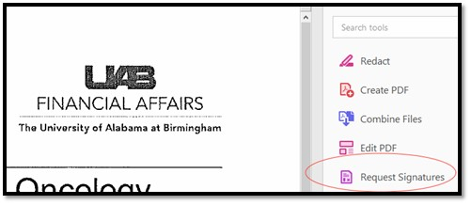

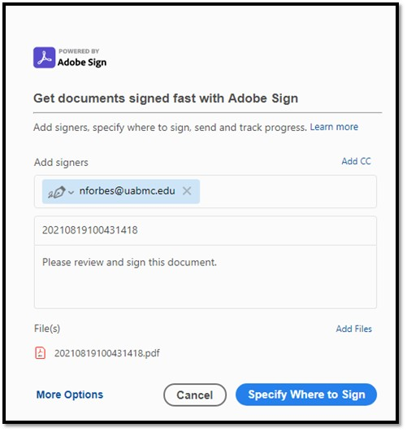

Please do not hesitate to email or call John Sides 205-934-4819 if you have any questions